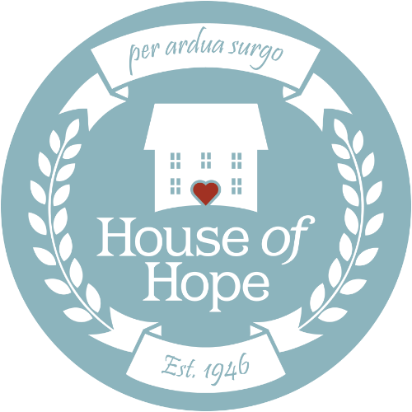

House of Hope Pre-Written Social Media Posts
Please feel free to copy and paste these posts to share on your social media network alongside your peer-to-peer fundraiser or to announce your participation in the virtual 5k on October 3, 2020.
Peer-to-Peer Fundraising Campaign
- I’m raising money for House of Hope to support women and children in recovery! House of Hope’s mission is treating substance use disorders, rebuilding lives, strengthening families, and empowering women. Every donation helps bring hope to Utah families. #HouseofHope #HouseofHopeUT #Donate #SocialGood
- I’m raising money for House of Hope, Utah’s oldest provider of substance use disorder treatment. Since opening in 1946, House of Hope has provided hope for thousands of Utahns and their families. Even small donations make a difference! #HouseofHope #HouseofHopeUT #Donate #SocialGood #TreatmentWorks
5k Participation Announcement
- On October 3, I’ll be participating in a virtual 5k to raise awareness for House of Hope. House of Hope’s mission is treating substance use disorders, rebuilding lives, strengthening families, and empowering women. #HouseofHope #HouseofHopeUT #TreatmentWorks
- House of Hope is Utah’s oldest provider of substance use disorder treatment. I’m participating in their virtual 5k on October 3! Please join me in this virtual 5k to support women in recovery. #HouseofHope #HouseofHopeUT #TreatmentWorks
Be sure to tag @HouseofHopeUT in all your posts—we love to hear why people are excited about our mission!

